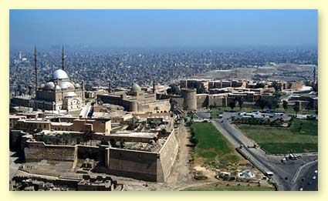
Egypt Feature Story
The Citadel in Cairo
by Jimmy Dunn
(04/07/2006): One of Cairo's most popular tourist attractions is the Citadel which houses a number of museums, ancient mosques and other sites, located on a spur of limestone that had been detached from its parent Moqattam Hills by quarrying. The Citadel is one of the world's greatest monuments to medieval warfare, as well as a highly visible landmark on Cairo's eastern skyline. Particularly when viewed from the back side (from the north), the Citadel reveals a very medieval character.
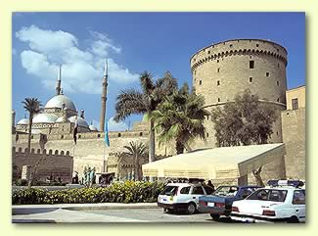
The area where the Citadel is now located began its life not as a great military base of operations, but as the "Dome of the Wind", a pavilion created in 810 by Hatim Ibn Hartama, who was then governor. Indeed this area was well known for its cool breeze. These early governors, not realizing its strategic importance, simply used the pavilion for its view of Cairo. Between 1176 and 1183, Salah ad-Din (Saladin to Westerners 1171-1193 AD), an Abbasid Ruler, fortified the area to protect it against attacks by the Crusaders, and since then, it has never been without a military garrison. Originally it served as both a fortress and a royal city.
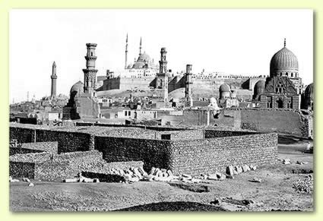
Legend has it that Salah ad-Din chose the site for its healthy air. The story goes that he hung pieces of meat up all around Cairo. Everywhere the meat spoilt within a day, with the exception of the Citadel area where it remained fresh for several days. But in reality this location provides a strategic advantage both to dominate Cairo and to defend outside attackers. Salah ad-Din had come from Syria where each town had some sort of fortress to act as a stronghold for the local ruler so it was only natural that he would carry this custom to Egypt.
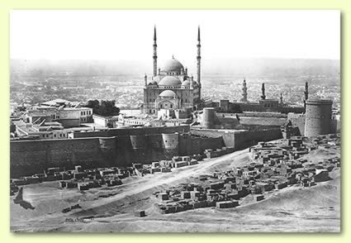
Salah ad-Din used the most modern fortress building techniques of that time to construct the original Citadel. Great, round towers were built protruding from the walls so that defenders could direct flanking fire on those who might scale the walls. The walls themselves were ten meters (30 ft) high and three meters (10 ft) thick.
The Bir Yusuf (Salah ad-Din's Well) was dug in order to supply the occupants of the fortress with an inexhaustible supply of drinking water. Some 87 meters (285 ft) deep, it was cut though solid rock down to the water table. It is not simply a shaft. There is a ramp large enough so that animals could descend into the well in order to power the machinery that lifted the water. Regrettably, the well is closed to tourists these days.
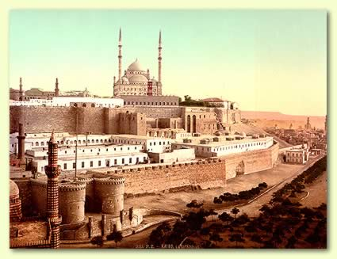
Most of the fortification was built after Salah ad-Din's rule, being added to by almost every invader including the British, some of whom destroyed much of what existed before them.
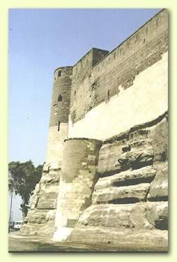
After the death of Salah ad-Din, his nephew, Al-Kamil, reinforced the Citadel by enlarging several of the towers. Specifically, he encased the Burg al-Haddad (Blacksmith's Tower) and the Burgar-Ramlab (Sand Tower) making them fully three times larger. These two towers controlled the narrow pass between the Citadel and the Muqattam hills. Al-Kamil also built a number of great keeps (towers) around the perimeter of the walls, three of which can still be seen overlooking the Citadel parking area. These massive structures were square, up to 25 meters (80 ft) tall and 30 meters (100 ft) wide. In 1218, upon the death of al-Kamil's father, now Sultan al-Kamil moved his residence to the Citadel where he built his palace in what is now the Southern Enclosure. While the palace no longer exits, until the construction of the Abdeen Palace in the mid-19th century, it was the seat of government for the Country of Egypt.
When the Mamluks finally overthrew the Ayyubid rulers in 1250, their sultan Baybars al-Bunduqdari (1260-77) moved into al-Kamil's palace. He isolated the palace compound by building a wall that divided the fortress into two separate enclosures linked by the Bab (gate) al-Qullah. The area where the palace once stood is referred to as the Southern Enclosure, while the larger part of the Citadel proper is referred to as the Northern Enclosure.
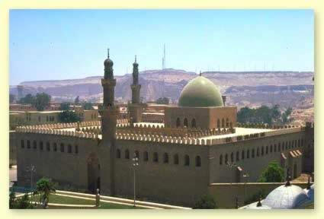
An-Nasir Muhammad, an interesting Sultan of this era who ruled during three separate periods (1294-1295, 1299-1309 and 1310-1341) tore down most of the earlier buildings in the Southern Enclosure and replaced them with considerably grander structures. Unfortunately, the only remaining facility built by him is the An-Nasir Mohammed Mosque. It was begun in 1318 and finished in 1355 and is located near the enclosure gate. We also know that he built a great Hall of Justice with a grand, green dome that towered above the other structures in the Southern Enclosure. Beside it was built the Qasr al-Ablaq (Striped Palace) with its black and yellow marble. This palace, used for official ceremonies and conducting affairs of state, had a staircase leading down to the Lower Enclosure and the Royal Stables where An-Nasir kept 4,800 horses.
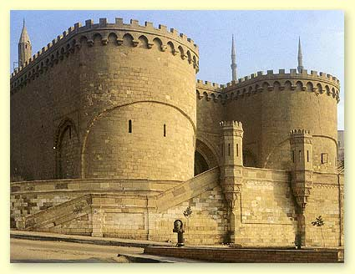
The Ottomans controlled Egypt in one way or another between 1517 and the early 20th century, except for a brief French occupation. Much of what we see of the Citadel actually dates from this period. The Lower Enclosure where the stables of An-Nasir came to be known as the al-Azab because some of the Ottoman soldiers, known as the Azab regiments, were stationed in the Lower Enclosure. These soldiers were not allowed to wed until after they retired, and in fact the word Azab can be translated as "bachelor".
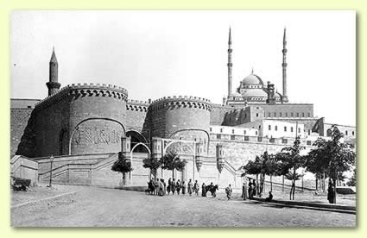
The Ottomans rebuilt the wall that separates the Northern and Southern Enclosures, as well as the Bab al-Quallah. They also built the largest tower in today's Citadel, the Burg al-Muqattam which rises above the entrance to the Citadel off Salah Saalem Highway. This tower is 25 meters (80 ft) tall and has a diameter of 24 meters (79 ft). In 1754 the Ottomans rebuilt the walls of the Lower Enclosure and added a fortified gate called the Bab el-Azab.
From the late 16th century until the French occupation, the strict military structure of the Ottoman soldiers gradually deteriorated. During this period, the Azab troops began to marry, and were even allowed to build their own housing within the fortress. By the mid 17th century, the Citadel had become an enclosed residential district with private shops and other commercial enterprises, as well as public baths and a maze of small streets.
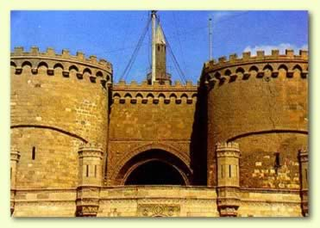
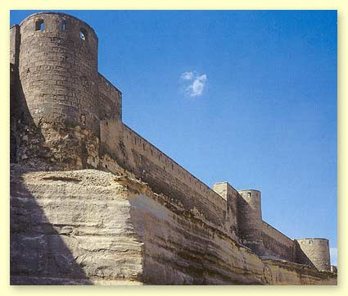
The Ottoman Muhammad Ali Pasha, one of the great builders of Modern Egypt, came to power in 1805, and was responsible for considerable alteration and building within the Citadel. He rebuilt much of the outer walls and replaced many of the decaying interior buildings. He also reversed the roles of the Northern and Southern Enclosures, making the Northern Enclosure his private domain, while the Southern Enclosure was opened to the public. His Mohammed Ali Mosque, built in the style called Ottoman Baroque that imitates the great religious mosques of Istanbul, today dominates the Southern Enclosure
South of the Mosque in the Hawsh is the Gawharah (Jewel) Palace. This structure was built between 1811 and 1814 and housed the Egyptian government until it was later moved to the Aberdeen Palace.
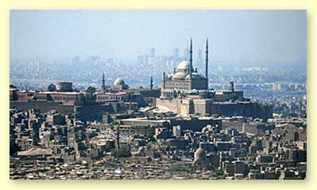
Today there is also a National Police Museum at the Citadel. It was built over the site of the Mamluk Striped Palace just opposite the Mosque of an-Nasir Muhammad. It has displays of law enforcement dating back to the dynastic period. However, in 1983 a hall from the Striped Palace was discovered buried deep beneath rubble, and can be seen at the southern end of this terrace. The terrace also provides a wonderful view of Cairo.
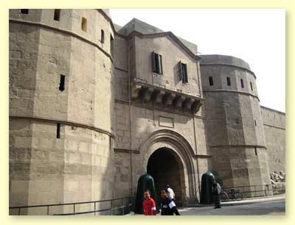
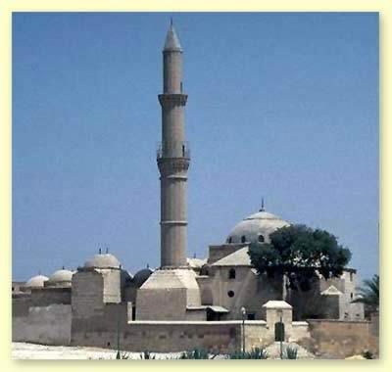
Just through the Bab al-Qullah in the Northern Enclosure one finds Muhammad Ali's Harem Palace that was built in the same Ottoman style as the Jewel Palace. The statue in front is of Ibrahim Pasha by Charles Cordier. The Palace served as a family residence for the Khedive until the government was moved to Aberdeen Palace. It was a military hospital during the British occupation and was only returned to Egyptian control after World War II. Since 1949, it has been the Military Museum of Egypt (founded by King Faruq). While the Museum has many artifacts illustrating warfare in Egypt, one of the most interesting attractions is the Summer Room. This room contains an elaborate system of marble fountains, basins and channels meant as a cooling system, and is probably the last such example in Cairo. In the livery court behind the carriage gate of the museum is a statue of Sulayman Pasha that originally stood in the city center. Just beyond this museum is a small Carriage Museum in what was the British Officer's mess until 1946. Borrowed from the larger Carriage Museum in Bulaq, it contains eight carriages used by the Muhammad Ali family. Just behind this museum is the Burg at-Turfah (Masterpiece Tower), one of the largest of the square towers built by al-Kamil in 1207.
Near the far end of the Northern Enclosure is the Suleyman Pasha Mosque. It was the first Ottoman style mosque built in Egypt and dates from 1528. It was built to serve the early Ottoman troops.
Today the Citadel is one of Egypt main attractions and is often the most popular non-Pharaonic monuments. One may walk through time here, from the medieval era onward. In addition, many other wonderful Islamic structures are nearby. For those with a little extra energy, a walk from the Citadel to the Khan el-Khalili is a delightful experience.
