
Sights
The Pharaonic Village is an experience like no other. The instant you begin sailing down the canals that circuit through the island you are immersed totally in the Egypt of history and legend. Everywhere you look, you will find more and more of the sights and sounds of ancient Egypt, until finally you could believe that you have truly traveled through time to a distant and glorious past. And some of the sights you will see are veritable masterpieces, faithful to their ancient originals in every detail.

The Yacht Nefertari Embarks on Another Spellbinding Tour
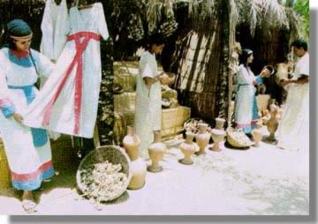
The Market is Only One of the Many Sights to See
Dr. Ragab and his staff have labored long to bring the Egypt of the pharaohs into the present, and you will not be disappointed. Every detail of the village has come about after years of careful study and research, some of it due to the work of the most famous Egyptologists in the world and collected by Dr. Ragab. Everything from the marketplace (above) to the palace of the pharaoh (below) is a work of art, lavishly painted and embellished just like the originals of centuries before. You will not be able to believe your eyes when you see the Pharaonic Village in all its glory.

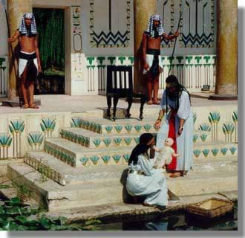
A Familiar Tale Comes to Life Before Your Eyes
Another sight not to miss at the Pharaonic Village is the replica of King Tutankhamen's tomb. The word "replica" actually does not do this wonder justice. Dr. Ragab and a team of archaeologists, engineers, and architects, along with specially selected Egyptian craftsmen, used Howard Carter's notes on the original tomb to reproduce faithfully the entire tomb, down to the tiniest ounce of treasure that had been placed with the boy king. Most of the reproduced artifacts made for the replica tomb were made entirely by hand using the same techniques that had made the originals, as Dr. Ragab insisted that the replicas be made as indistinguishable from the originals as possible. Many of the artifacts took years to create at enormous cost, but every single one is there, from the silver and gold jewelry to the great golden throne to the alabaster canopic jars.
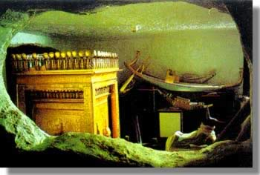
The Replica of the Tomb of Tutankhamen
This reproduction is vastly superior to an ordinary museum, for the treasures here are arranged in precisely the manner as they were in the original tomb before Carter opened it. There are very few differences between this one and the original, as Dr. Ragab and his staff are very thorough in their work, but, as he adds with a smile, "our tomb is air-conditioned."
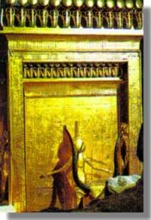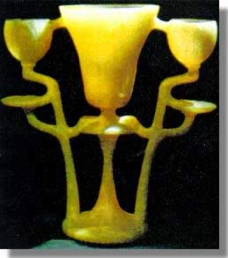
Are They Originals or Copies? The Attention to Detail is Astonishing
This replica of Tutankhamen's tomb and the artifacts within is a most important contribution to the study and preservation of ancient Egypt. The original, in the Valley of the Kings, is sometimes closed to the public because the moisture from the breath of 3000 visitors a day was beginning to destroy the ancient tomb paintings. The replica at the Pharaonic Village is the only way for the average person to see King Tutankhamen's tomb as it was at the time of its discovery. Thanks to Dr. Ragab and the Pharaonic Village, visitors can still visit a wonder of history without fear of it being lessened for future generations.
The Pharaonic Village is not a collection of static and unchanging exhibits. Rather, it is a living, breathing entity that changes day by day with numerous activities from ancient Egypt. The ancient Egyptians were not so different from us, actually. They worked hard at their daily jobs and greatly enjoyed recreation time. The "inhabitants" of the Pharaonic Village have worked to recapture these daily activities and bring them to life for you. From work to play, industries and festivals, there is always something new going on in the Pharaonic Village.
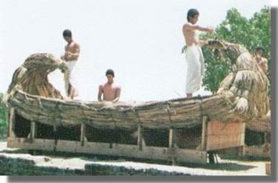
Boat Building by Traditional Methods
The shipwrights shown above are duplicates of those that lived thousands of years ago and built boats for fishing, commerce, and travel. With the Nile as the major route of travel, boat building was an important industry in ancient Egypt, and so it is also a prominent part of the Pharaonic Village, joining other ancient industries such as brickmaking, carpentry, and masonry.
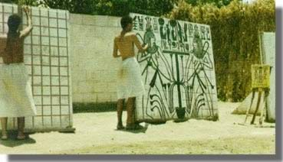
Some Local Artisans Work on Temple Paintings
The ancient Egyptians loved art and their modern counterparts are no different. All over the Pharaonic Village, artisans work to create elaborate masterpieces using ancient styles and techniques, carefully researched to ensure a high level of realism. Painters, sculptors, scribes and even potters are all present in the Pharaonic Village, each one working on a very special project for the village. Many of the artifacts created will go on to enrich the authenticity of the village and the enjoyment of your tour, and in fact, all of the paintings, sculptures, and statues you see on your tour were created within the boundaries of the village by these artisans.
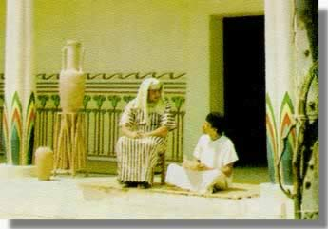
A Nobleman Relaxes at His Home
Recreation too, was important, then as now. Egypt has always been blessed with the perfect weather for all activities, especially fun ones. The ancient Egyptians enjoyed many of the pastimes that we do today: sports, games, performances, or just a quiet conversation at home. As you tour the Pharaonic Village, all these activities that made up the daily lives of the ancient Egyptians from merchants to peasants will be shown to you.

All Content Copyright © 2000-2004 by InterCity Oz, Inc.

