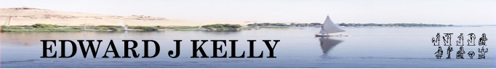
In association with MAX TRAVEL .
Affordable Tailor-made Holidays and Trips to Egypt

Highlights Tour - Itinerary

Day 1: Depart the UK for Cairo.

Upon arrival in Egypt you will be met by our representative and assisted with visas and transit through the airport to board your coach for the journey to your hotel. Your rooms will already be prepared and waiting for you to take immediate occupancy. This will give you an opportunity to freshen up.

Depending upon your flights and time of arrival, you might wish to retire to bed or orientate yourself with the hotel and its immediate locality.

Day 2: Visit to the Giza Plateau - the pyramids of Khufu, Khafra and Menkaura and the Tombs of the Nobles. Followed by a visit to the Sphinx, the Sphinx Temple and the Valley Temple of Khafra.

An afternoon visit will be made to the Egyptian Museum in Cairo

Dinner will be taken at your hotel and the evening will be free for you to relax or explore the local nightlife.

Day 3: Morning visit to Sakkara and the Stepped Pyramid Complex of Djoser.

Lunch will be taken at a local, high quality, restaurant.

In the afternoon, sit back and relax as you enjoy a boat ride back in time where your visit to the Pharaonic Village will bring to life the history of Ancient Egypt.

In the evening you will board the sleeper-train for your overnight journey to Luxor. Dinner will be served in your cabin onboard the train and after dinner you can take advantage of the first class club car.

Day 4: Breakfast onboard the train prior to arrival at Luxor.

Dawn visit to Karnak Temple followed by check-in at hotel.

Free afternoon for rest or to take part in one of the many optional excursions.

Evening visit to Luxor Temple and a local market followed by Dinner and overnight in Luxor.

Day 5: Morning visit to the West Bank (Valley of the Kings, Tombs of the Nobles or Temple of Hatshepsut. Felucca ride on the Nile

Free afternoon and prepare for journey to Hurghada.

Convoy departure to Hurghada.

Day 6: Free time to enjoy the Red Sea area.

There is the opportunity to take part in snorkelling, a Red Sea boat trip and a Desert Quad-bike Safari & Bedouin Barbecue.

Dinner and overnight in Hurghada.

Day 7: Free morning in Hurghada and time to pack for start of journey home.

Join convoy for return journey to Cairo and connect to airport for return journey home.

NB. Throughout the trip breakfast is usually taken in the hotel before leaving for the day's excursions.

Lunch will be taken at around midday in excellent local restaurants.

Dinner, each evening, is usually served in the hotel unless otherwise stated.

Airport transfers in Egypt and all transport throughout the trip is included. Entrance fees to the sites of antiquities, museums, etc are included, (except for optional excursions taken during free time).

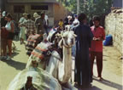 | 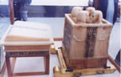 | 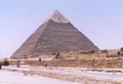 | 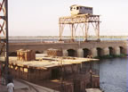 | 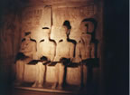 | 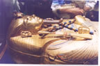 | 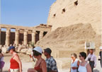 | 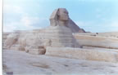 | 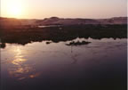 | 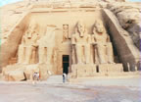 | 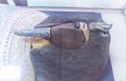

EDWARD J KELLY – PO Box 151, Liverpool, L17 0WS tel: 0151 291 0778 mob: 07967 025 687
email egypt@edwardjkelly.com WWW.edwardjkelly.com/egypt.htm

MAX TRAVEL – Business Village, 3-9 Broomhill Road, London, SW18 4JQ. tel: +44 (0) 20 8877 5770 fax: +44 (0) 20 8877 5771 email: info@maxtravel.co.uk WWW.maxtravel.co.uk

