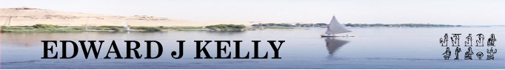
In association with MAX TRAVEL .
Affordable Tailor-made Holidays and Trips to Egypt

Classic Tour & Nile Cruise - Itinerary

Day 1: Flights to Egypt.

Upon arrival in Egypt you will be met by our representative and assisted with visas and transit through the airport to board your coach for the journey to your hotel. Your rooms will already be prepared and waiting for you to take immediate occupancy. This will give you an opportunity to freshen up.

Depending upon your flights and time of arrival, you might wish to retire to bed or orientate yourself with the hotel and its immediate locality.

Day 2: Visit to the Giza Plateau – The Great Pyramid of Khufu and pyramids of Khafra & Menkaura, the Giza Necropolis and the Sphinx. Visit the Egyptian Museum at Cairo and see the treasures of Tutankhamen as well as a host of other splendours from Ancient Egypt. The bravest of adventurers can even visit the mummy room.

Day 3: Visit to Sakkara – The Stepped Pyramid of Djoser and the Tombs of the Nobles, including that of Merrerukka. Travel to Luxor, overnight on sleeper-train.

Day 4: Board our luxury 5* cruise ship for a Four-Day Nile Cruise to Aswan on a Full Board basis. Visit to Karnak and Luxor Temples.

Day 5: Visit to the West Bank and The Valley of the Kings, The Mortuary Temple of Hatshepsut or The Tombs of the Nobles, The Colossi of Memnon (Amenhotep III), sail to Edfu.

Day 6: Visit Edfu Temple, dedicated to the Egyptian god Horus and sail on to Kom Ombo Temple, dedicated to the Egyptian god Sobek.

Day 7: Upon reaching Aswan, as well as seeing the Aswan High Dam and viewing the Unfinished Obelisk, there will be an opportunity (as an optional excursion) to take a felucca or motorboat cruise on the Nile that takes you on a meandering journey through the massive boulders of the first cataract and onwards through the lush foliage to visit a Nubian Village.

Day 8: There will be a great opportunity (as an optional excursion) to take a flight and visit the famous temple of Abu Simbel, where Ramesis II deified himself and where his statue can be seen in the inner sanctuary in communion with three of the main gods of the New Kingdom - Ra-Horakhty, Ptah and Amun-Ra. There is also the lesser or smaller temple dedicated to his wife – Nefertari.

Day 9: Flight back to Cairo and onwards to UK

In either Cairo or Luxor there will be visits to a papyrus institute and a perfumery where you will have the opportunity to see how papyrus is made and witness the expertise of the Egyptian Perfumers as they blend any fragrance of perfume or aftershave you can imagine. There is no obligation to buy anything during these visits but they are very interesting and informative.

There will also be opportunities to take part in a number of optional excursions, including: A Hot-air balloon ride at dawn, over the Valley of the Kings and the Theban Necropolis (you can even see Howard Carter’s house); A camel ride at the pyramids at Giza; The Sound and light show at the Pyramids or at Karnak Temple; The Pharaonic Village at Cairo.

As an alternative, it is possible to visit Hurghada to enjoy a relaxing time by the Red Sea. As well as relaxing and sunbathing, there are a number of other activities that can be pursued, including, a quad-bike safari into the desert and enjoying a Bedouin barbeque and snorkelling in the Red Sea.

NB. Throughout the trip breakfast is usually taken in the hotel or onboard the cruise ship before leaving for the day's excursions.

Lunch will be taken at around midday in excellent local restaurants.

Dinner, each evening, is usually served in the hotel or onboard the cruise ship unless otherwise stated.

Airport transfers in Egypt and all transport throughout the trip is included. Entrance fees to the sites of antiquities, museums, etc are included, (except for optional excursions taken during free time).

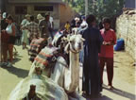 | 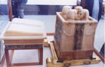 | 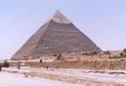 | 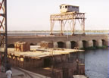 | 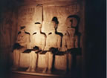 | 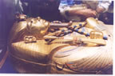 | 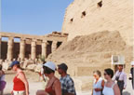 | 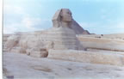 | 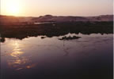 | 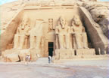 | 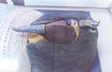

EDWARD J KELLY – PO Box 151, Liverpool, L17 0WS tel: 0151 291 0778 mob: 07967 025 687
email egypt@edwardjkelly.com WWW.edwardjkelly.com/egypt.htm

MAX TRAVEL – Business Village, 3-9 Broomhill Road, London, SW18 4JQ. tel: +44 (0) 20 8877 5770 fax: +44 (0) 20 8877 5771 email: info@maxtravel.co.uk WWW.maxtravel.co.uk

