The land of Egypt is truly a historical delight, but it's not just the ancient Egyptians who left their mark for all to see, so too did the Copts, the early Christians from just after the time of Christ.
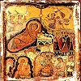 | 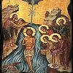 | 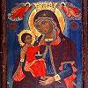 | 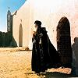 | 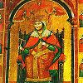
A brief introduction to Coptic Egypt
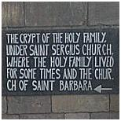
The term Copt or Coptic is a corruption of the Greek word "Aegyptios" (or Aigyptos) meaning Egyptian. Aigyptos derived from the Ancient Egyptian "Ha-ka-Ptah" meaning "the house of the Ptah". Through its use in Arabic, "qubt" or "qibt", it became known as "Copt".
The modern use of the term "Coptic" refers to both the Egyptian Christians themselves, and the final stage of the language of the Ancient Egyptians. It also describes the art and architecture that developed as an early expression of this "new" faith.
The Coptic Church is based upon the teachings of St Mark, who brought Christianity to Egypt in around 50 AD. St Mark was one of the four gospels (Matthew, Mark, Luke and John) and the gospel of St Mark is the oldest canonical gospel.
A small community of Christians developed in Alexandria in the late first century, and became more numerous by the end of the second century. The Egyptians embraced the new faith, and Christianity quickly spread throughout Egypt within half a century of St Mark's arrival in Alexandria. Some similarities in beliefs helped Christianity to be accepted by Egyptians, including the beliefs that the Egyptian god Osiris was both human and god, the resurrection of Osiris, and the godly triad of Osiris, Isis, and Horus.
There are many sites throughout Egypt at which the holy family are said to have taken shelter and sought refuge during the three years that they spent in Egypt after fleeing from Judea and King Herod. Many ancient churches have been built upon these sites.
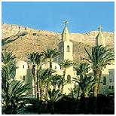 | 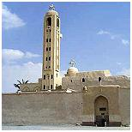 | 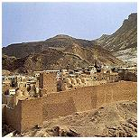
Coptic monastery of St Anthonys | Coptic monastery of St Bishoi | Coptic monastery of St Pauls
The persecution of the Christians
It was around the third-fourth centuries AD, that the Romans had taken to persecuting the followers of various other religious beliefs, Christians in particular. The Roman emperor Diocletian, attempting to restructure and unify the Roman Empire, introduced new harsh reforms which led to a rebellion in Egypt. This in turn led to further extensive persecutions of Christians, many of whom were martyred for their beliefs. This period is now referred to by Copts as the "Era of Martyrs", and the year of Diocletian's accession (284 AD) was designated Year One in the Coptic Christian calendar in order to observe the tragedies.
The beginning of monasticism
The emperor Constantine ended the persecutions of Christians in 313 AD with the Edict of Milan, which declared general religious tolerance throughout the Roman Empire. Later, Constantine established Christianity as the state religion of the eastern Roman Empire, and it was around that time that the tradition of monasticism began in Egypt, with "holy men" retreating into caves in the desert to live like hermits. Followers of these hermits established monasteries in inaccessible and isolated areas, and many of these original monasteries still survive today, some still complete with monks, icons, furnishings and the trappings of the simple lifestyle that date back almost to the time of Christ.
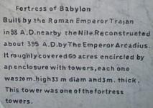
Old Coptic Cairo (Masr al-Qadima): This area is the oldest part of Cairo, and predates what is now modern Cairo. It is believed that there was a settlement here as early as the 6th century BC. Later, the Romans built a fortress here which we know today as "Babylon". Some of these Roman walls still exist today.
After the spread of Christianity throughout Egypt, it became a Christian stronghold, with as many as twenty churches built within an area of just one square mile. Now only five remain, along with the earliest mosque ever built in Egypt. After the fall of Jerusalem in around 70 AD, the area saw an influx of Jews, and it's here where Egypt's oldest synagogue, Ben Ezra is located.
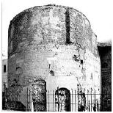 | 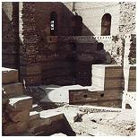 | 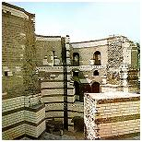
Roman tower at Babylon Fort, Old Cairo. | Roman remains at Babylon Fort, Old Cairo. | Roman remains at Babylon Fort, Old Cairo.
Churches within Old Cairo include:
ABU SERGA: The church of St Sergius, Cairo. Considered to be Cairo's oldest church, dating from the 4th century AD. Built on the spot where the Holy Family rested at the end of their journey into Egypt. |  | SITT BARBARA: The church of Saint Barbara, Cairo. Exact date of construction unknown. Burnt in the Fustat fire of 750 AD and restored during the 11th century.
KENISET MAR GIRGIS: The church of Saint George, Cairo. Originally built in 684 and rebuilt in 1857. It is best known for its wedding chamber, which dates from the 4th century AD and was reserved for marriage ceremonies. |  | MAR GIRGIS: The Greek church of Saint George, Cairo. Round church, built on a Roman tower. Burnt in 1904 rebuilt 1909. The church here has been Greek Orthodox since the 15th century.
EL-MU'ALLAQA: The hanging church, Cairo. Cairo's most famous church, may have been originally built in the 7th century on the site of an older 4th century church. Built on top of the Roman walls. |  | The Church of the Holy Virgin in Babylon Al-Darag, Qasr el-Sham, Cairo. Dates from the 11th century, and is situated just outside Old Cairo in Qasr el-Sham.
The Churches and Convents of Harat Zuwaila in Old Cairo: The church of Saint George (Upper church), The church of the Virgin Mary, and the church of Saint Mercurius. Situated in the Fatimid area of Cairo. Tradition holds this district was blessed by the Holy Family during their travels in Egypt. |  | MAR MINA: The church of Saint Menas, Cairo (with the annexed churches of Saints Benham and George). Probably dates back to the 6th century AD, but rebuilt during the 8th century. The cupolas were added in 1164.

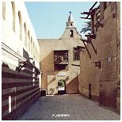 | 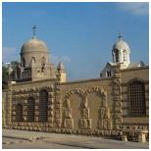 | 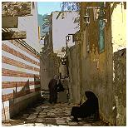
Street in Old Cairo. Street levels here are considerably lower than the modern street level. | Decorative wall outside the cemetery in Old Cairo. | Narrow cobbled streets in Old Cairo.

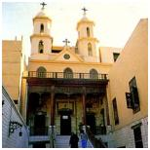 | 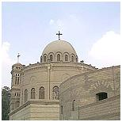 | 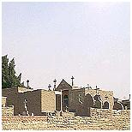
The Hanging Church (el-Muallaqa) dates from around the 7thC and is actually built on top of the walls of the Roman fort. | Mar Girgis Church (St.George) is built on top of a Roman tower. It was rebuilt in 1909 after being destroyed by fire. | The Coptic cemetery, Old Cairo.
Although Old Cairo contains a concentration of Christian churches and monuments, most of the really ancient Christian churches of Egypt are to be found in the isolated monasteries of the Eastern Desert. What is believed to be the world's oldest monastery, St Anthony's, was established in the middle of the fourth century AD by the Red Sea coast in the Eastern Desert in Egypt.

